Media Kit

Jules Rothacher
Overview
as Jules is going was started as a way for Jules, a mom of three kids 2.5-years-old and younger at the time, to have a creative outlet. It has since brought her back to this place of loving to write again. It’s warm, inviting, and honest.
When Jules began this journey, she promised she would share all of the real in life. She had read too many blogs that lead mom’s to leave feeling they are failing, other moms can accomplish so much, or that mommy-hood is a waste of time. She wanted as Jules is going to be a place where moms can be encouraged, grow closer to God, and find Christ in all aspects of life, even down to recipes, diaper changing, DIY projects, and loving on neighbors.
Jules has a fun way of sharing day-to-day stories with her readers that can bring tears and laughs all while pointing everything back to Christ. Jules is also very short and concise when writing tutorials and recipes as to show respect for her readers’ time so they’re not digging through ramblings to get to the good stuff.

Audience
Traffic from April-May Month:
Unique Visitors: 3,006
Visits: 3,381
Page views: 4521
Pages / Visit: 1.34
Avg. Visit Duration: 00:01:00
RSS & Email Subscribers: 24+
Facebook Personal: 1,394+
Gender: Female 93.1%  Age: 25-34 48.5% | 85% New Visitors  15% Returning Visitors
Jules has a degree in Psychology with a minor in sociology that seems to help her in countless ways to understand and relate to her children, friends and family, as well as readers. Speaking as an educated mom brings other educated mom’s to a relatable place.
Jules over two years of experience in the blogging world and has learned a great amount in a short time. She has spent countless hours learning from experts in the field of blogging. A few of the things she has learned that benefit her blog are how to compose a well-crafted blog post, creating quality images that will go viral on Pinterest, as well as how to use social media to her advantage.
Having been all over the state of Arkansas, Jules fell in love with social media as a way of staying in contact with friends miles away. In the past couple years she has seen how these forms of media she was already taking part in could enhance the aJig community. She is on Facebook, Twitter, and Instagram daily and all of her posts get pinned to Pinterest. Jules has purposely limited herself on how many different networks she is using so she may focus on utilizing them to their full extent.
Social Media Footprint
Facebook Fan Page: 260+
Facebook Personal Page: ~1400
Twitter: 210+
Pinterest: 750+
Instagram ~230
Google Page Rank: 2
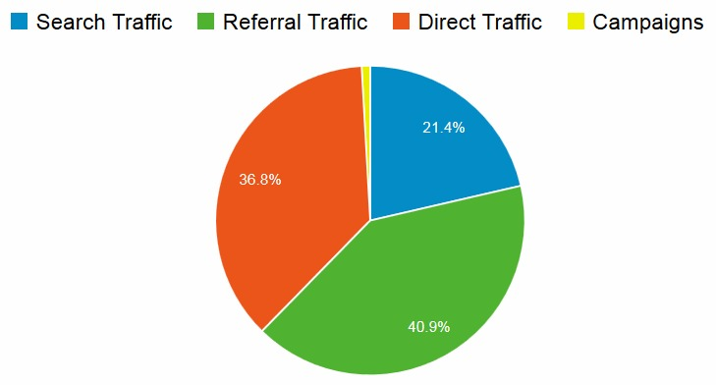
You can see that as Jules is going hits both the dedicated reader who has joined this community as well as the Pinterest/Google searching reader looking for a straight forward how-to.

Content
as Jules is going has rich content about real everyday life. Jules is a mom with 3 {1 on the way} little blessings born all within five and a half years, a wife of a hilarious, creative, loving, godly man, and together their family has been in youth ministry for the past 10 years. The newest adventures include homeschooling and church planting where they are focusing on the de-church population {a fast growing demographic}.
In everything Jules writes she attempts to ‘disciple’ those who stop by her little slice of the net. Disciple, simply meaning: train, model, and encourage readers to do everything for the glory of Christ. Even practical things such as recipes, DIY projects, deal and new products are all part of everyday life that can bring glory to God’s name. Jules doesn’t believe something has to have a bible verse stamped on it or even be “Christian based” to glorify Him although Jules will not support things that defame His name. Her prayer is that the message of aJig will be universal and can “make disciples of all nations”.
Here is where as Jules is going has landed thus far:
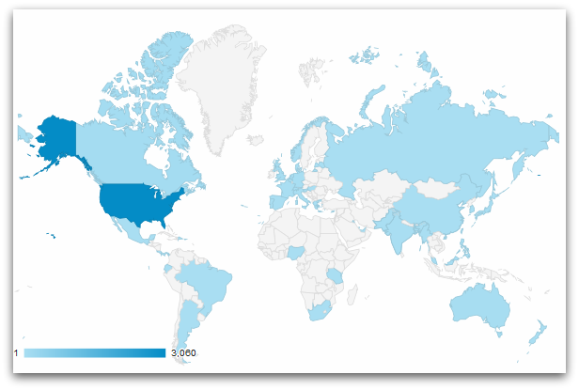
Benefits
- aJig has limited advertising so your ad will have prime real estate.
- aJig readers have confidence in the products and companies that are advertised there because they know the site is very guarded with who and what is featured.
- aJig content is regularly linked to multiple high traffic sites via link-up parties.
- aJig has several pingbacks on other sites and has been a on guest on the Vivienne McNeny radio show.
- aJig gets lots of cross traffic from Jules contributing to the Homemaker’s Challenge as well as A Common Bond at least once a month.
Ad Formats/Pricing
At this time as Jules is going is only accepting image {button} advertising that must be provided by the sponsor. Jules can create images for an additional fee.
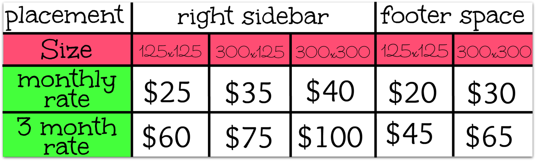

You can find sample buttons on the bottom of THIS post.

Guest Post Pricing
At this time, as Jules is going is only accepting exclusive guest post {from those wishing to share about their business or product}. All post must meet Jules normal guest post guidelines.
Do keep in mind that most readers will be more interested in your business or product if you conduct a giveaway along with your guest post.
At this time, for an accepted guest post charge is $75 for post that is allowed one permanent link within the post, to be on the blog for as long as the blog is live {a minimum of 6 months}. With the normal monthly charge of $25 a month, that’s a minimum 50% discount!

Other Pricing
If you haven’t found anything that meet your advertising needs, contact me and we’ll see what can be worked up.

Ad Payment
At this time as Jules is going is only accepting payment via PayPal. More information on this will be provided via email when Jules and the sponsor have chosen when advertising will start.
Ad Policy
- No refunds on ads.
- I reserve the right to refuse any ad based on content of the ad or the product or site being promoted.
- All ads must reflect the values of as Jules is going.

